 



Database Programming with SQL 13-1: Creating Tables

Practice Activities

# Objectives

* List and categorize the main database objects
* Review a table structure
* Describe how database schema objects are used by the Oracle database

# Vocabulary

Identify the vocabulary word for each definition below.

|  |  |
| --- | --- |
| **Data dictionary** | Created and maintained by the Oracle Server and contains information about the database |
| **Schema** | A collection of objects that are the logical structures that directly refer to the data in the database |
| **DEFAULT** | Specifies a preset value if a value is omitted in the INSERT statement |
| **TABLE** | Stores data; basic unit of storage composed of rows and columns |
| **CREATE TABLE** | Command use to make a new table |

# Try It / Solve It

1. Complete the GRADUATE CANDIDATE table instance chart. Credits is a foreign-key column referencing the requirements table.

|  |  |  |  |  |  |
| --- | --- | --- | --- | --- | --- |
| Column Name | student_id | last_name | first_name | credits | graduation_date |
| Key Type | Primary key |  |  | Foreign key |  |
| Nulls/Unique | NO/YES | NO/NO | NO/NO | No/NO | YES/NO |
| FK Column |  |  |  | credits |  |
| Datatype | NUMBER | VARCHAR2 | VARCHAR2 | NUMBER | DATE |
| Length | 6 |  |  | 3 |  |

1. Write the syntax to create the grad_candidates table.

CREATE TABLE graduate_candidates

( student_id NUMBER(6,0),

last_name VARCHAR2(75) CONSTRAINT gcs_last_name_nn NOT NULL ENABLE,

first_name VARCHAR2(75) CONSTRAINT gcs_first_name_nn NOT NULL ENABLE,

credits NUMBER(5,2) CONSTRAINT gcs_credits_nn NOT NULL ENABLE,

graduation_date DATE,

CONSTRAINT gcs_std_id_pk PRIMARY KEY (student_id),

CONSTRAINT gcs_req_fk FOREIGN KEY(credits) REFERENCES requirements(credits) ENABLE

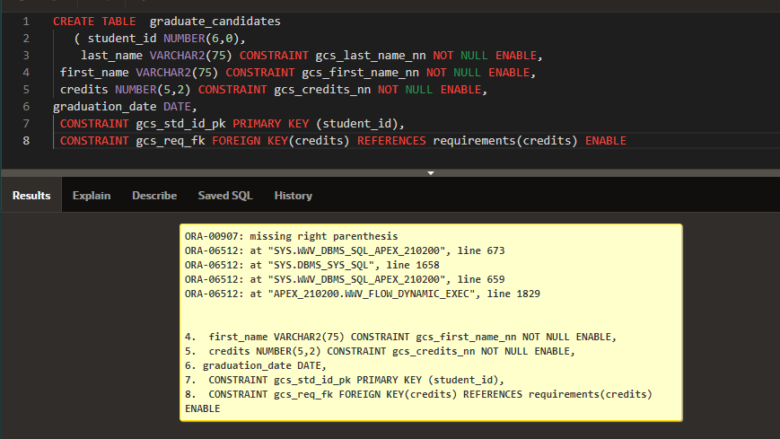

Так как credits не существует, без нее создастся

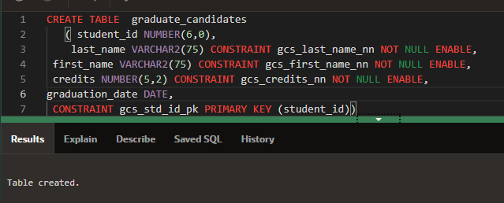

1. Confirm creation of the table using DESCRIBE.

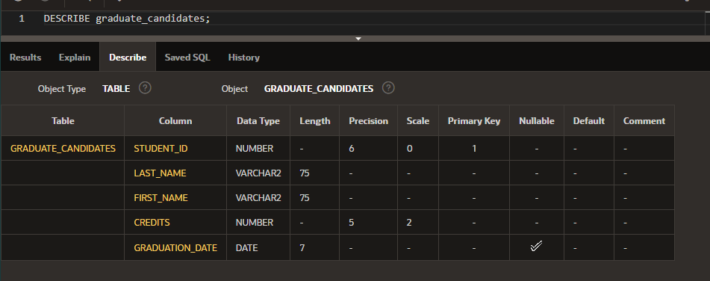

1. Create a new table using a subquery. Name the new table your last name -- e.g., smith_table. Using a subquery, copy grad_candidates into smith_table.

CREATE TABLE Borisov_Nikita_Table

AS ( SELECT * FROM graduate_candidates);

1. Insert your personal data into the table created in question 4.

INSERT INTO Borisov_Nikita_Table (student_id, last_name, first_name, credits, graduation_date)

Values(10,'Borisov','Nikita', 743.12,NULL);

Select * from Borisov_Nikita_Table

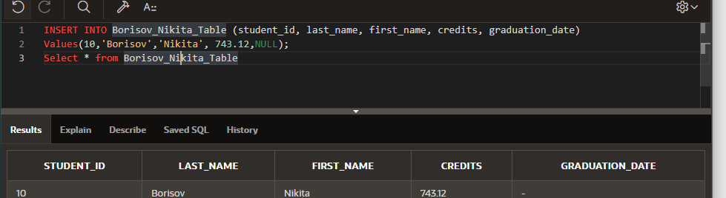

1. Query the data dictionary for each of the following:
   * USER_TABLES
   * USER_OBJECTS
   * USER_CATALOG or USER_CAT

In separate sentences, summarize what each query will return.

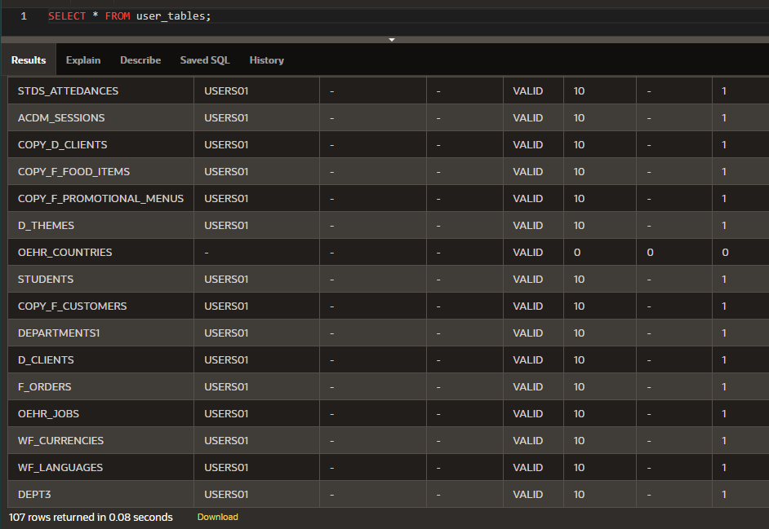

Количество таблиц моего пользователя

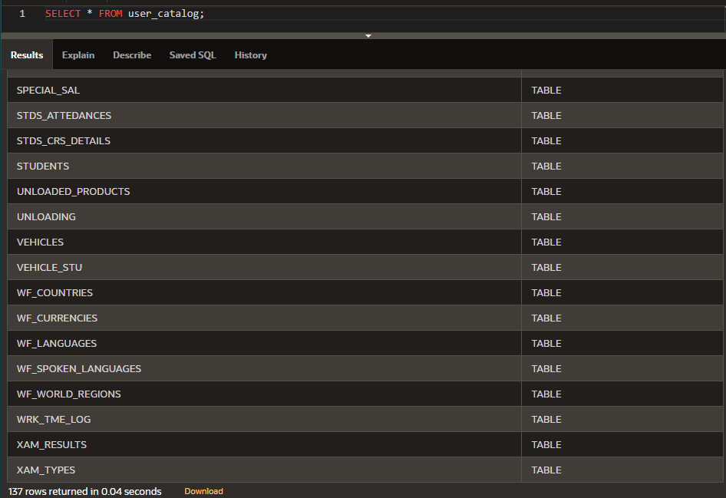

Выводит индексы, таблицы, представления, кластеры, синонимы и последовательности

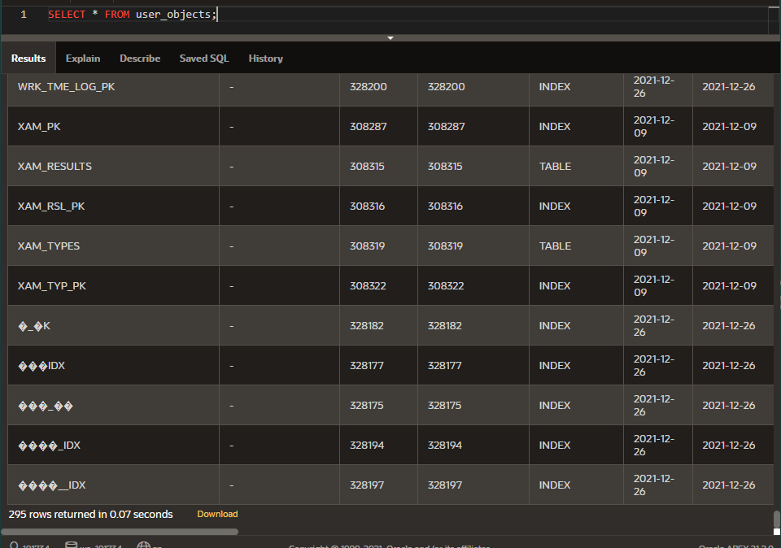

Все объекты моего пользователя (текущего)

Copyright © 2020, Oracle and/or its affiliates. All rights reserved. Oracle and Java are registered trademarks of Oracle and/or its affiliates. Other names may be trademarks of their respective owners.